**Lesson 2: Adding and Subtracting Integers**

positive positive

negative negative

Opposites

absolute value

-9 -18

8 15

**Do Now:**

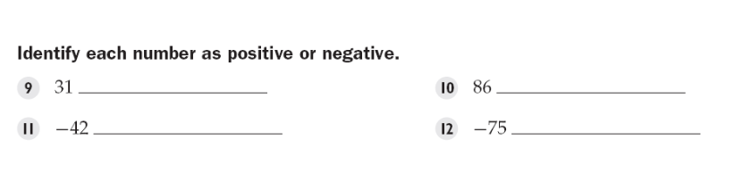

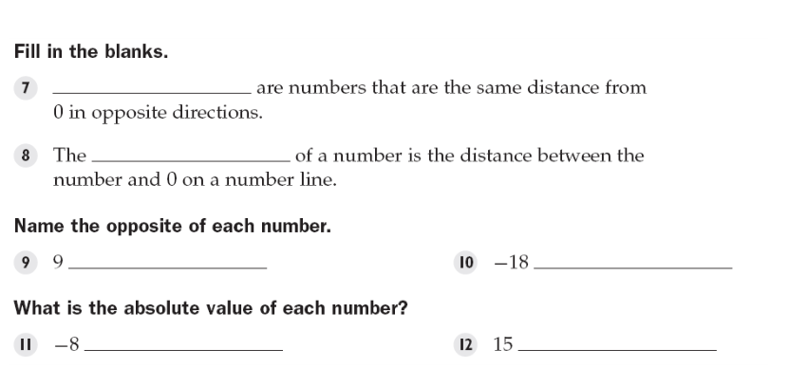

**Key Vocabulary:**

**Guided Notes:**

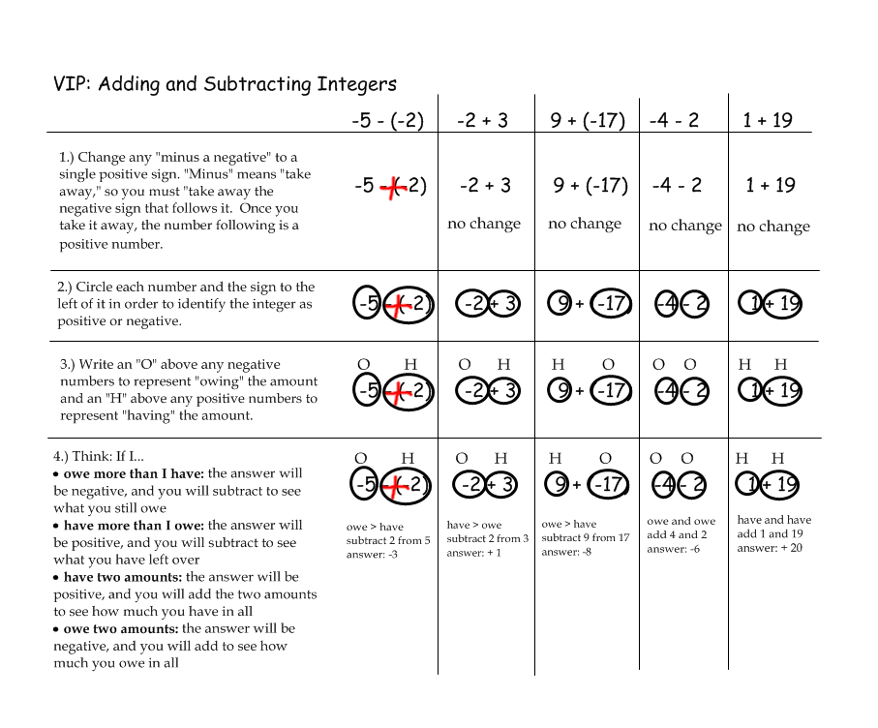

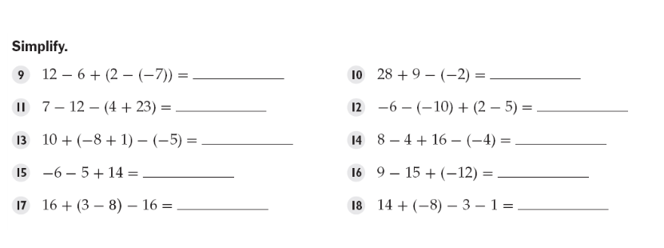

15 39

-32 1

8 24

3 -18

-5 2

**Structured:**

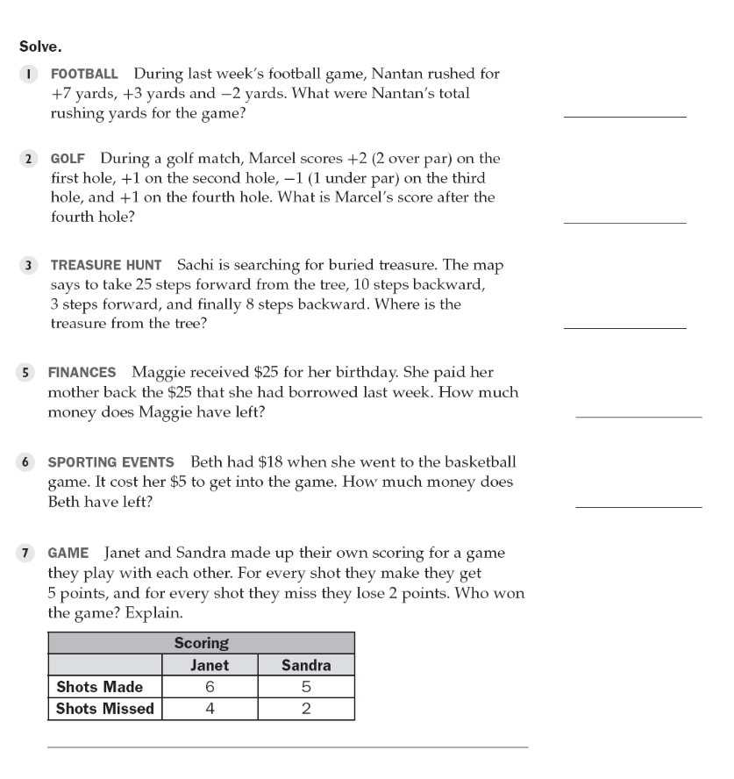

8

3

10 steps forward

$0

$13

Janet: 22 (wins)

Sandra: 21

Guided Practice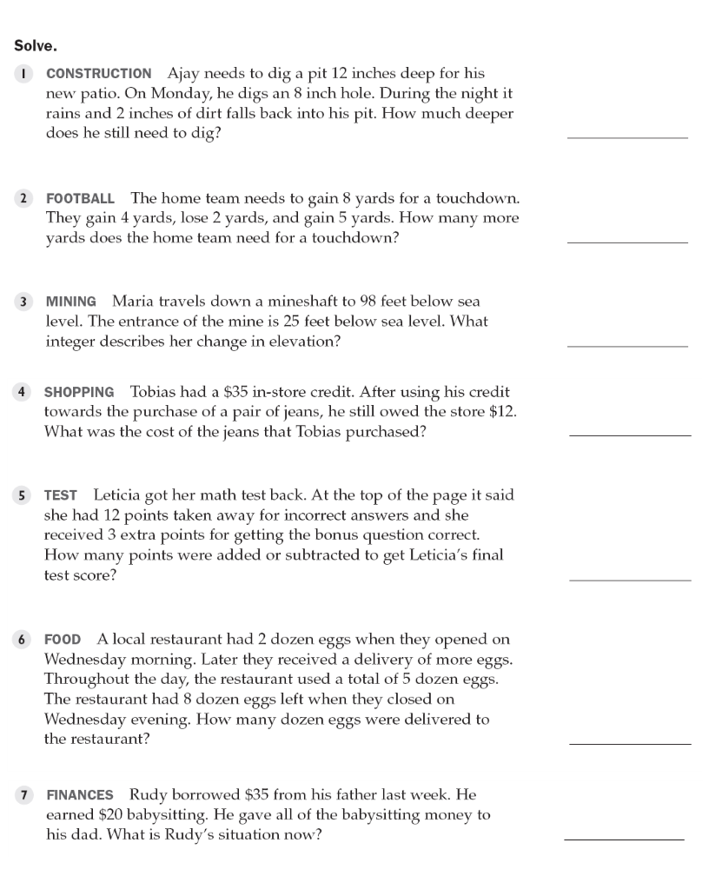

6 inches

1 yard

73 feet

$47

9 points subtracted

11 dozen

-$15

**Independent Practice:**

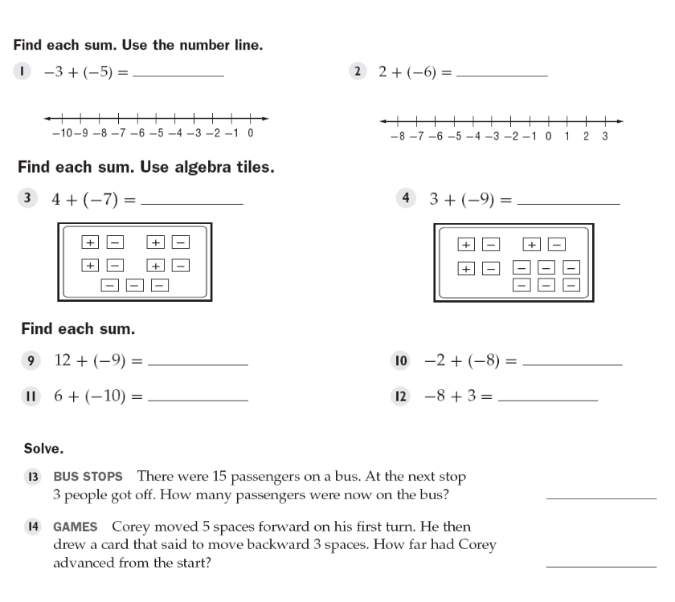

-8 -4

-3 -6

3 -10

-4 -5

12

2

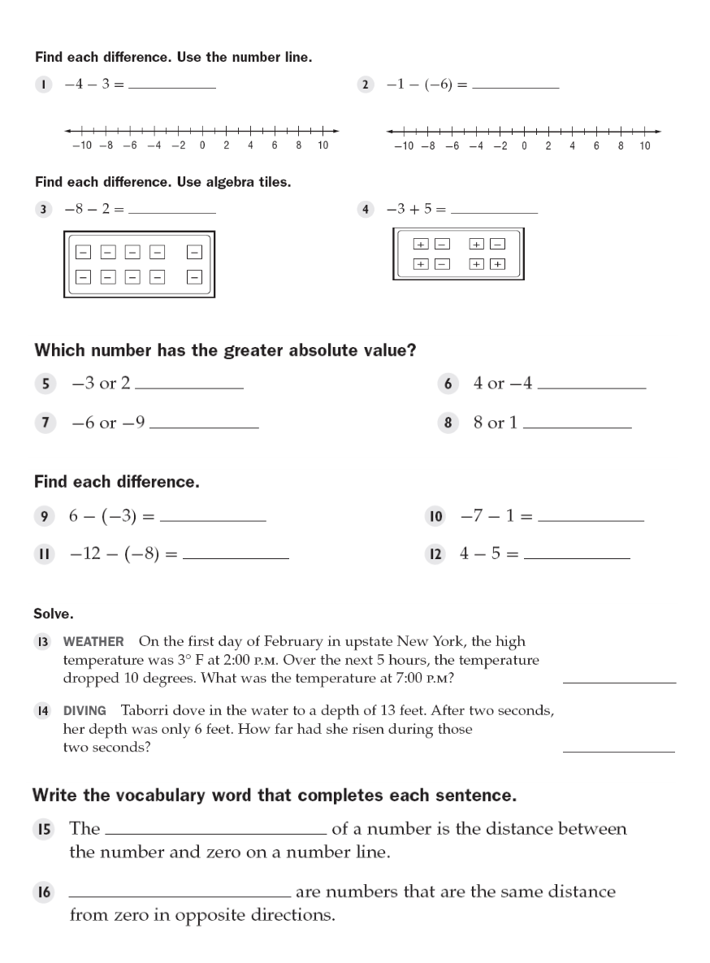

-7 5

-10 2

-3 same

-9 8

9 -8

-4 -1

-7 degrees

7 feet

absolute value

Opposites